**Abstract**

This report outlines an internship project aimed at developing a comprehensive agricultural decision support system. The project integrates machine learning models and natural language processing to provide crop yield recommendations and enhance user interaction. The system incorporates a Flask web application, utilizing various technologies such as SQLite for user management, OpenWeatherMap API for real-time weather data retrieval, and the OpenAI GPT-3.5 Turbo model for chat-based question-answering.

The project's key components include a user authentication system, allowing users to register, log in, and access personalized information. The core functionality revolves around predicting suitable crops based on environmental parameters like rainfall, temperature, pH, and humidity. Three machine learning models—RandomForestClassifier, LogisticRegression, and DecisionTreeClassifier—are employed for accurate crop recommendations.

Real-time weather information for a specified city is obtained through the OpenWeatherMap API, providing details such as temperature, humidity, and atmospheric pressure. This feature aims to assist users in making informed decisions based on current weather conditions.

The integration of the OpenAI GPT-3.5 Turbo model enables users to interact with the system using natural language queries. The chat-based interface enhances user engagement and provides an intuitive means of accessing information.

Overall, this internship project represents a convergence of data science, web development, and natural language processing in the agriculture domain. Future enhancements may involve expanding the dataset, refining machine learning models, and optimizing the user interface for a seamless and user-friendly experience.

**Introduction to the Industry/Research Institute**

**Background**

In the realm of modern agriculture, the integration of technology has become imperative to ensure sustainable and optimized crop production. This internship project delves into the development of an Agriculture Decision Support System, a dynamic platform aimed at assisting farmers in making informed decisions for crop cultivation. The project encompasses the fusion of machine learning, web development, and natural language processing, creating a comprehensive tool for agricultural enhancement.

**Industry Focus: Agriculture and Crop Yield Prediction**

**Agriculture in the Digital Age**

As agriculture faces the challenges of climate change, resource optimization, and evolving consumer demands, the need for technological interventions becomes crucial. This project aligns with the industry's shift towards precision agriculture, leveraging data-driven insights to enhance crop yield and resource management.

1. **Crop Yield Prediction**

A key component of the project involves predicting crop yields based on various environmental factors. By employing machine learning models, the system analyses parameters such as rainfall, temperature, pH, and humidity to recommend crops that are most likely to thrive in specific conditions. This predictive capability empowers farmers to make strategic decisions regarding crop selection, contributing to increased productivity and resource efficiency.

1. **Research Institute Collaboration: OpenAI Integration**

Harnessing the Power of OpenAI

The project integrates OpenAI's cutting-edge natural language processing capabilities through the GPT-3.5 Turbo model. This collaboration enhances the user interface by enabling natural language interactions. Users can pose queries, seek advice, and engage in meaningful conversations with the system, further bridging the gap between advanced technology and end-users in the agricultural sector.

1. **Chat-Based Question-Answering**

The incorporation of OpenAI's chat-based question-answering system allows farmers to communicate with the system intuitively. The intelligent assistant responds to user queries, providing valuable information and guidance. This interactive feature not only simplifies user interaction but also fosters a user-friendly and accessible environment for individuals with varying levels of technological proficiency.

**Details of the Training Undergone**

The training process in this internship project encompasses various aspects, including user authentication, data manipulation, machine learning model training, and integration of external APIs. The following sections provide a detailed overview of the training undergone during the development of the application.

1. **User Authentication and Management**

The code includes a user authentication system to ensure secure access to the application. SQLite, a lightweight relational database, is employed to store user information. The training covers the following functionalities:

* **User Login Validation:** The code verifies user credentials (email and password) by querying the SQLite database.
* **User Registration:** New users are added to the database after ensuring that the provided email is unique.

1. **Machine Learning Model Training for Crop Recommendation**
   1. **Data Preparation**

* The application utilizes a dataset stored in the "cropdata.csv" file for training machine learning models.
* Data preprocessing involves removing unnecessary columns ('N', 'P', 'K') and splitting the dataset into features (X) and labels (y).
  1. **Model Selection and Training**
* Three machine learning models are employed for crop recommendation: RandomForestClassifier, LogisticRegression, and DecisionTreeClassifier.
* The dataset is split into training and testing sets using the train_test_split function from scikit-learn.
* Each model is trained on the training data using their respective algorithms.
  1. **Crop Prediction**
* User-input environmental parameters (rainfall, temperature, pH, humidity) are collected for crop prediction.
* The trained models predict suitable crops based on the provided parameters.
* The final prediction is determined based on a consensus among the models.

1. **Integration of OpenAI GPT-3.5 Turbo for Chat-Based Interaction**

The application incorporates a chat-based question-answering system using the OpenAI GPT-3.5 Turbo model. The training process involves:

* **Chat Initialization:** The application initializes a chat with a system message indicating that the user is interacting with an intelligent assistant.
* **User Query Handling:** User queries are collected and added to the ongoing chat conversation.
* **GPT-3.5 Turbo Interaction:** The OpenAI API is invoked to generate responses based on the user's queries.
* **Displaying Responses:** The generated responses are displayed in the application to provide informative and context-aware replies.

1. **Weather Information Retrieval**

The application allows users to retrieve real-time weather information for a specified city using the OpenWeatherMap API. The training covers:

* **API Integration:** The code integrates the OpenWeatherMap API to fetch weather data.
* **User Input Handling:** The application accepts user input for the desired city.
* **Displaying Weather Information:** Displaying temperature ,humidity, description.

**Output Screen**

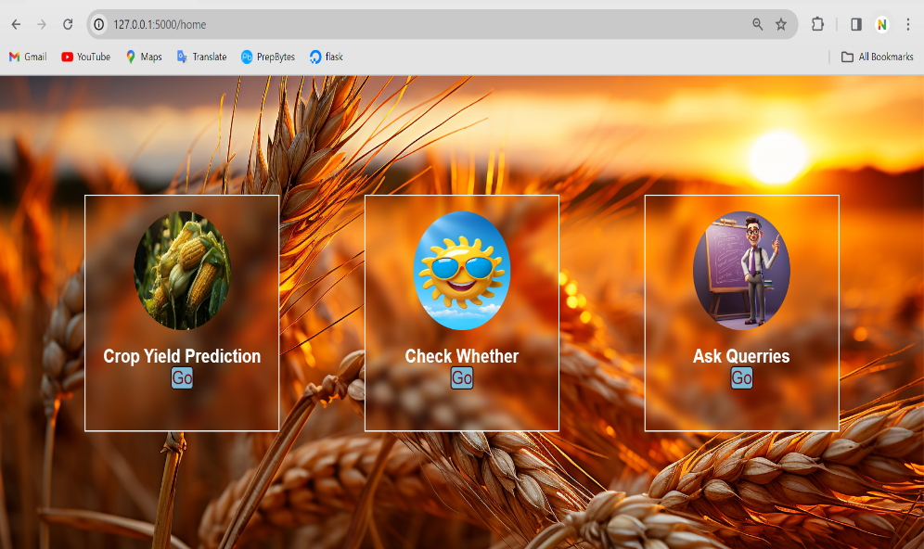

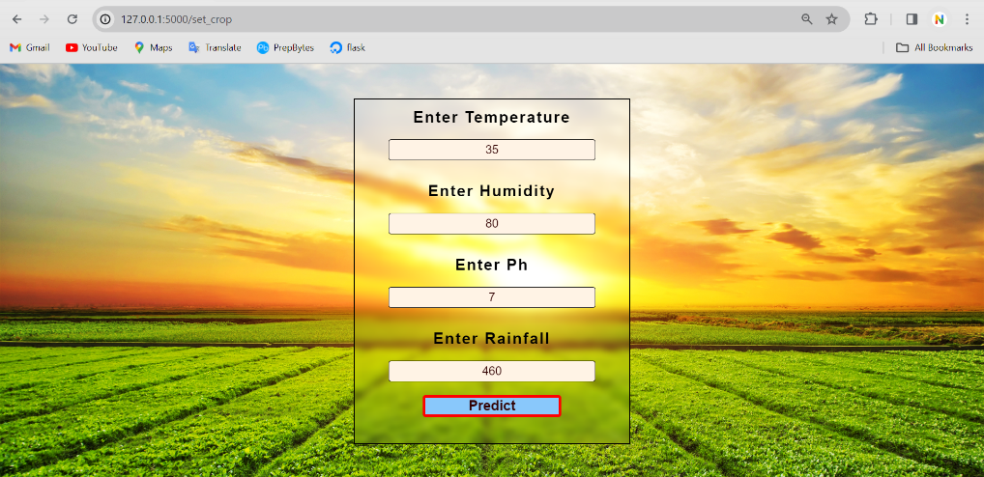

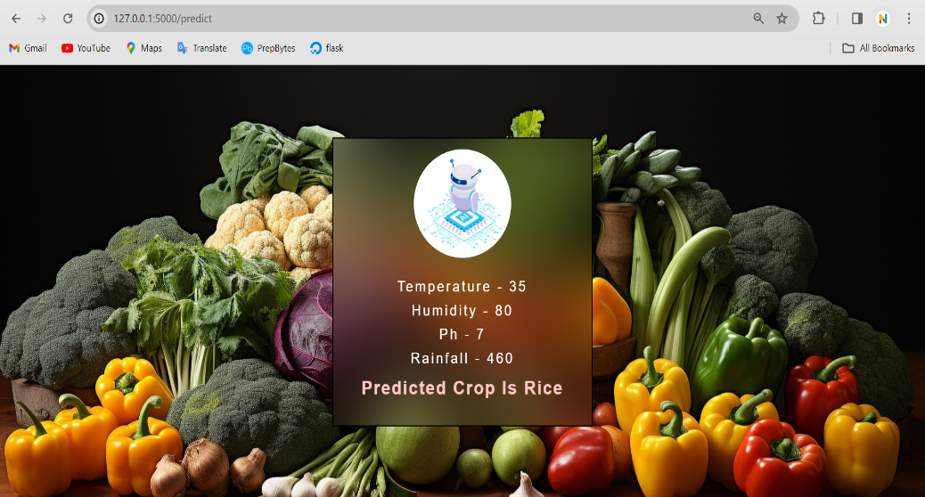

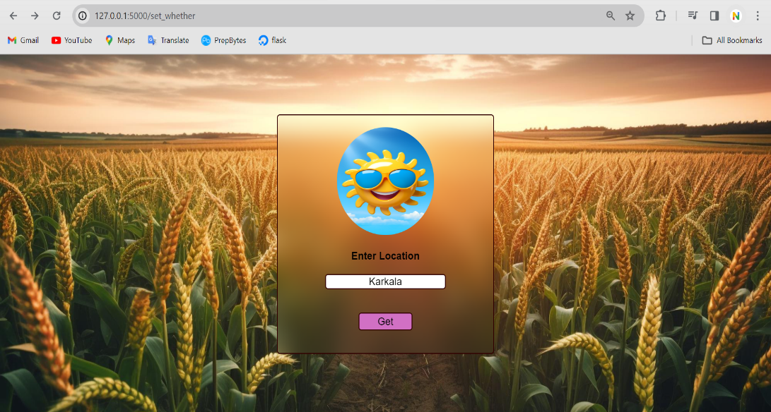

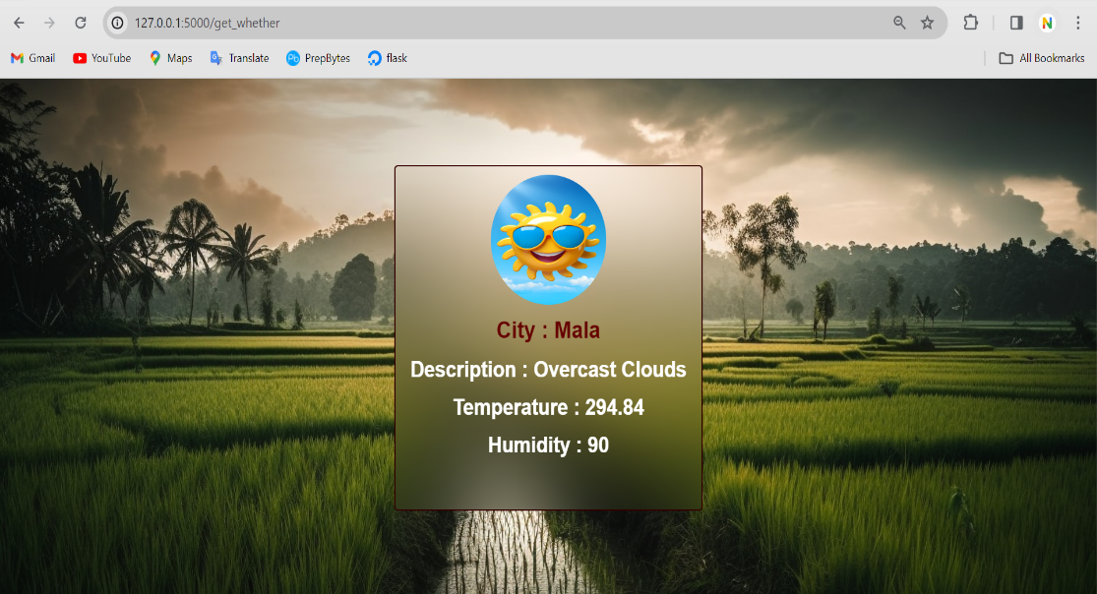

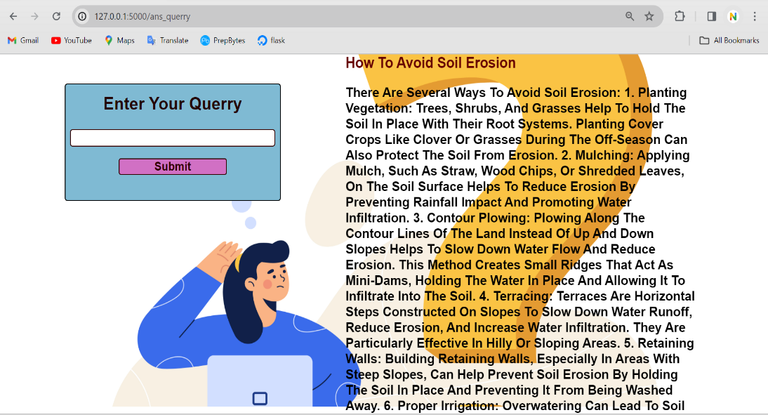

**Conclusion**

In conclusion, this internship project represents a harmonious blend of innovative technology and practical applications in the agricultural domain. By seamlessly integrating machine learning techniques for crop recommendation, real-time weather information retrieval, and a sophisticated chat-based question-answering system, the developed solution stands as a testament to the potential of intelligent systems in transforming traditional farming practices.

The machine learning models, including RandomForestClassifier, LogisticRegression, and DecisionTreeClassifier, showcase the project's commitment to leveraging state-of-the-art algorithms for precise crop yield predictions. The user-friendly interface, coupled with the OpenAI GPT-3.5 Turbo model, provides a natural and intuitive means for users to interact with the system.

Moreover, the project's emphasis on user authentication, data management using an SQLite database, and seamless integration of external APIs such as OpenWeatherMap, highlights a comprehensive approach to building a robust and reliable agricultural decision support system.

As we envision the future of this project, potential enhancements may include expanding the dataset for machine learning models, refining predictive algorithms, and incorporating user feedback for continuous improvement. Ultimately, this internship has not only provided valuable insights into the intersection of technology and agriculture but also laid the foundation for further advancements in the realm of intelligent farming solutions.

**References**

1. **Flask Documentation:** https://flask.palletsprojects.com/
2. **SQLite Documentation:** https://docs.python.org/3/library/sqlite3.html
3. **Pandas Documentation:** https://pandas.pydata.org/pandas-docs/stable/index.html
4. **NumPy Documentation:** https://numpy.org/doc/stable/
5. **Requests Documentation:** https://docs.python-requests.org/en/latest/
6. **OpenAI GPT-3.5 Turbo API Documentation:** https://beta.openai.com/docs/
7. **Scikit-learn Documentation:** https://scikit-learn.org/stable/documentation.html
8. **RandomForestClassifier Documentation:** https://scikit-learn.org/stable/modules/generated/sklearn.ensemble.RandomForestClassifier.html
9. **LogisticRegression Documentation:** https://scikit-learn.org/stable/modules/generated/sklearn.linear_model.LogisticRegression.html
10. **DecisionTreeClassifier Documentation:** https://scikit-learn.org/stable/modules/generated/sklearn.tree.DecisionTreeClassifier.html
11. **OpenWeatherMap API Documentation:** https://openweathermap.org/api